000님 session 00
Life Without Parole & The Cone of Trust

Modern Family — Two Stories from the Dunphy Family
Part 1 Phil & Claire's Honeymoon Story (0:19) https://www.youtube.com/shorts/NVMOZWvzl3k
Part 2 The Cone of Trust (1:00) https://www.youtube.com/shorts/uzO7aN9N8ZI
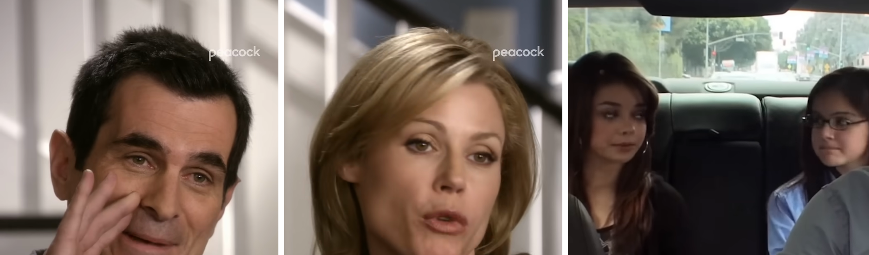

Warm-Up
Q Have you ever watched Modern Family or any other American sitcom?
Q When you were a teenager, were you closer to your mom or your dad? Why?
Q Is there a family tradition you did every year when you were young?
Q Do you prefer a big wedding or a small, simple wedding? Why?

000님 session 00
Part 1 — Script

Phil & Claire's Honeymoon Story
This is exactly what they say in the video. Listen first, then read it aloud.

Phil: Actually, Claire and I were supposed to go to Hawaii for our honeymoon, but something else came up.

Claire: I got pregnant with Haley.

Phil: My bad!

Claire: We didn't even have a proper wedding. We just went down to the courthouse on a Tuesday.

Phil: The judge sentenced me to life with no chance of parole.

Claire: You begged me to marry you.

Phil: It's true, I did.

000님 session 00
Part 1 — Useful Expressions

be supposed to ~
to be planned or expected to do something
+ was supposed to ~, but …
+ be planning to ~
Ex) I was supposed to meet my friends last weekend, but I had to cancel my plans.

something (else) came up
something unexpected happened, so the plan changed
+ Something came up at work.
+ I can't make it.
Ex) Sorry, I can't make it tonight. Something came up.

get pregnant (with ~)
to start to have a baby
+ be pregnant
+ be expecting (a baby)
Ex) My sister got pregnant with her second baby last year.

My bad!
an informal way to say "It's my fault. Sorry."
+ That's on me.
+ Sorry about that.
Ex) My bad! I forgot to text you back.

not even ~ / a proper ~
not even = not something as basic as ~ / proper = real, as it should be
+ I didn't even have time to eat.
+ a proper meal
Ex) I was so busy that I didn't even have a proper lunch.

go down to ~
to go to a nearby place (casual)
+ go down to the beach
+ run down to the store
Ex) Let's go down to the café after class.

sentence someone to ~
(a judge) to officially give someone a punishment
+ life with no chance of parole
+ a life sentence
Ex) The man was sentenced to ten years in prison.

beg someone to ~
to ask someone for something very strongly
+ beg for ~
+ I'm begging you!
Ex) My kids begged me to buy them a puppy.

000님 session 00
Part 2 — Script

The Cone of Trust
This is exactly what they say in the video. Listen first, then read it aloud.

Alex: Tell him.

Phil: Tell me what?

Haley: Nothing.

Phil: Hey, what do we call daddy's car, girls?

Haley & Alex: The cone of trust.

Phil: The cone of trust. Exactamundo. Where you can speak your mind with no judgment.

Phil: So, what is it? Boys? Your bodies are changing? Eggs?

Haley: No! No.

Haley: We were just thinking that maybe...

Phil: Mm-hmm.

Haley: If... if you're open to it...

Haley: Dad, we love you, but we do not want to go to family camp this year.

Haley: Dad? Are you upset?

Phil: Nope.

Haley: Then what was that sniff?

Phil: Sniff? What sniff? I'm... I'm, uh... I'm actually relieved. The day that I've been dreading, uh, the day when you two finally outgrow me, has finally arrived, and I'm handling it really well.

Haley: Dad, are you crying?

Phil: Nope.

Haley: Are you sure you're okay?

Phil: Yep.

Haley: Oh, my God. He is crying.

Alex: I've never seen Dad cry before.

Haley: But, Dad, if you cry, then I'll cry!

Phil: I'm not crying.

Haley: We made our daddy cry!

000님 session 00
Part 2 — Useful Expressions

speak your mind
to say honestly what you think
+ Feel free to speak your mind.
+ be honest with ~
Ex) In our team meetings, everyone can speak their mind.

(with) no judgment
without criticizing someone
+ a judgment-free zone
+ judge someone
Ex) You can tell me anything. No judgment.

be open to ~
to be willing to try or accept something
+ I'm open to suggestions.
+ open-minded
Ex) I'm open to trying new food when I travel.

be upset (about ~)
to feel unhappy or worried because of something
+ Don't be upset.
+ upset about the news
Ex) She was upset because she missed her flight.

relieved
feeling happy because something bad is over or did not happen
+ What a relief!
+ I'm relieved to hear that.
Ex) I was so relieved when the exam was over.

dread (doing) ~
to feel very worried about something that will happen
+ I've been dreading this day.
+ dreadful
Ex) I've been dreading my dentist appointment all week.

outgrow ~
to become too big or too old for something
+ outgrow clothes / toys
+ grow out of ~
Ex) My son has already outgrown his new shoes.

handle ~ (really) well
to deal with a difficult situation successfully
+ deal with ~
+ cope with ~
Ex) She handled the stress at work really well.

000님 session 00
Dictation

Listen to the videos and fill in the blanks. You can listen two or three times.

Part 1

1. Claire and I were _____________ _____________ go to Hawaii for our _____________, but something else _____________ _____________.

2. I got _____________ with Haley.

3. My _____________!

4. We didn't even have a _____________ _____________.

5. We just went down to the _____________ on a _____________.

6. The judge _____________ me to life with no chance of _____________.

7. You _____________ me to marry you.

8. It's _____________, I _____________.

Part 2

9. Where you can speak your _____________ with no _____________.

10. We were just _____________ that maybe...

11. If... if you're _____________ _____________ it...

12. We do not want to go to family _____________ this year.

13. Dad? Are you _____________?

14. I'm actually _____________.

15. The day that I've been _____________, the day when you two finally _____________ me

16. I'm _____________ it really well.

17. I've never _____________ Dad _____________ before.

000님 session 00
Check & Discuss

Comprehension — Did you catch it?
Watch the videos and answer the questions.

Part 1

Q Where were Phil and Claire supposed to go for their honeymoon?

Q Why couldn't they go?

Q What does Phil say about it?

Q How did they get married?

Q What does Phil compare his marriage to?

Q Who wanted to get married more, Phil or Claire?

Part 2

Q Where are Phil and the girls?

Q What does Phil call his car?

Q What do the girls want to tell Phil?

Q How does Phil say he feels?

Q How does he really feel? How do you know?

Q What happens at the end?

Discussion — What do you think?

Q Have you ever had plans that changed because something came up?

Q When you were young, did you have a place where you could talk honestly with your parents, like the cone of trust?

Q Have you ever had to tell someone something they didn't want to hear? How did you say it?

Q Phil cries when his daughters 'outgrow' him. Do you think it's hard for parents when their kids grow up?

Q In Part 1 Phil jokes that marriage is a life sentence, but in Part 2 he cries over his daughters. What kind of person is Phil?

Q Phil jokes that getting married was like a life sentence. Do people make jokes like this in Korea?

000님 session 00
Role-Play & Your Turn

Role-Play — Break the News Gently
Read Part 2 in three roles. Then pick a card and break the news gently.

Card 1 Tell your boss you can't join the company dinner this Friday.
Card 2 Tell your best friend you don't want to go on the trip you planned together.
Card 3 Tell your parents you can't come home for the holidays this year.

Useful patterns: We were just thinking that maybe... / If you're open to it... / I love you, but... / Are you upset?

Your Turn — Tell Your Own Story
Tell your own story using the pattern below.

1. I was supposed to _________________________, but something came up.

2. What happened? _________________________

3. How did you feel? _________________________

Q Retell Part 1 or Part 2 as if you are telling a friend. Use at least three expressions from today.

000님 session 00
Review Quiz

Fill in the blanks with the expressions in the box.

supposed to / came up / My bad / proper / begged / speak your mind / relieved / outgrown

1. Sorry, I can't come tonight. Something _____________.

2. I was _____________ meet my friend, but I had to cancel.

3. _____________! I forgot to call you back.

4. I was so busy that I didn't have a _____________ lunch.

5. My kids _____________ me to buy them a puppy.

6. This is a judgment-free zone. Feel free to _____________.

7. I was so _____________ when the test was over.

8. My son has already _____________ his shoes.

